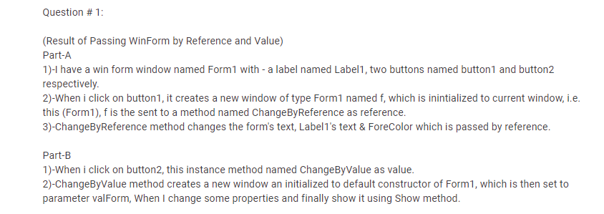

**Code:**

using System;

using System.Collections.Generic;

using System.ComponentModel;

using System.Data;

using System.Drawing;

using System.Linq;

using System.Text;

using System.Threading.Tasks;

using System.Windows.Forms;

namespace WindowsFormsApp2

{

public partial class Form1 : Form

{

public Form1()

{

InitializeComponent();

}

private void button1_Click(object sender, EventArgs e)

{

Class1 c1 = new Class1();

Form1 f2 = new Form1();

c1.reference(ref f2 );

f2.Show();

}

private void button2_Click(object sender, EventArgs e)

{

Form1 f1 = new Form1();

Class1 c1 = new Class1();

c1.value(this);

f1.Show();

}

}

}

**Class Code:**

using System;

using System.Collections.Generic;

using System.ComponentModel;

using System.Data;

using System.Drawing;

using System.Linq;

using System.Text;

using System.Threading.Tasks;

using System.Windows.Forms;

namespace WindowsFormsApp2

{

class Class1

{

public void reference(ref Form1 referForm)

{

Form1 f2 = referForm;

f2.label1.Text = "This is reference Form";

f2.Text = "reference form";

f2.label1.ForeColor = Color.Red;

}

public void value(Form1 valform)

{

Form1 f1 = new Form1();

f1 = valform;

f1.Text = "Value Window";

f1.label1.Text = "change by Value";

f1.label1.ForeColor = Color.Blue;

}

}

}

**OUTPUT:**

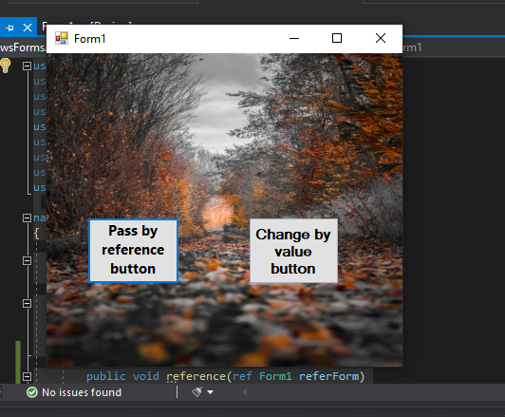

**RUN:**

